**Homework 2**

**CSE 5120 (Section 02) – Introduction to Artificial Intelligence – Spring 2022**

*Submitted to*

**Department of Computer Science and Engineering**

**California State University, San Bernardino, California**

by

Corbin Ulloa (006973376)

Date: March 18, 2022

Email:

* 006973376@coyote.csusb.edu

**Report**

1. **Minimax algorithm**

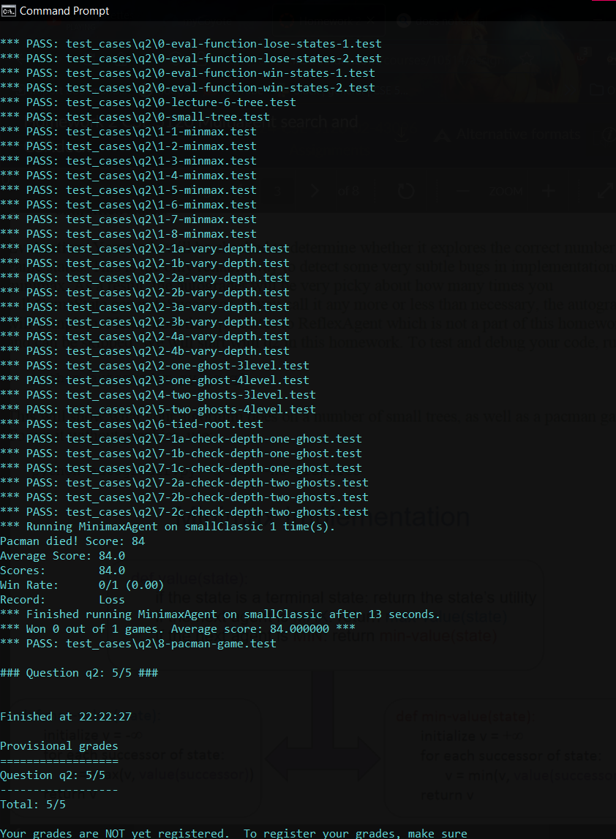My code expands the game tree to an arbitrary depth and has multiple min layers for each ghost in every max layer.

1. **Alpha-beta pruning**  
   Code uses alpha-beta pruning to explore the minimax tree more efficiently in AlphaBetaAgent.

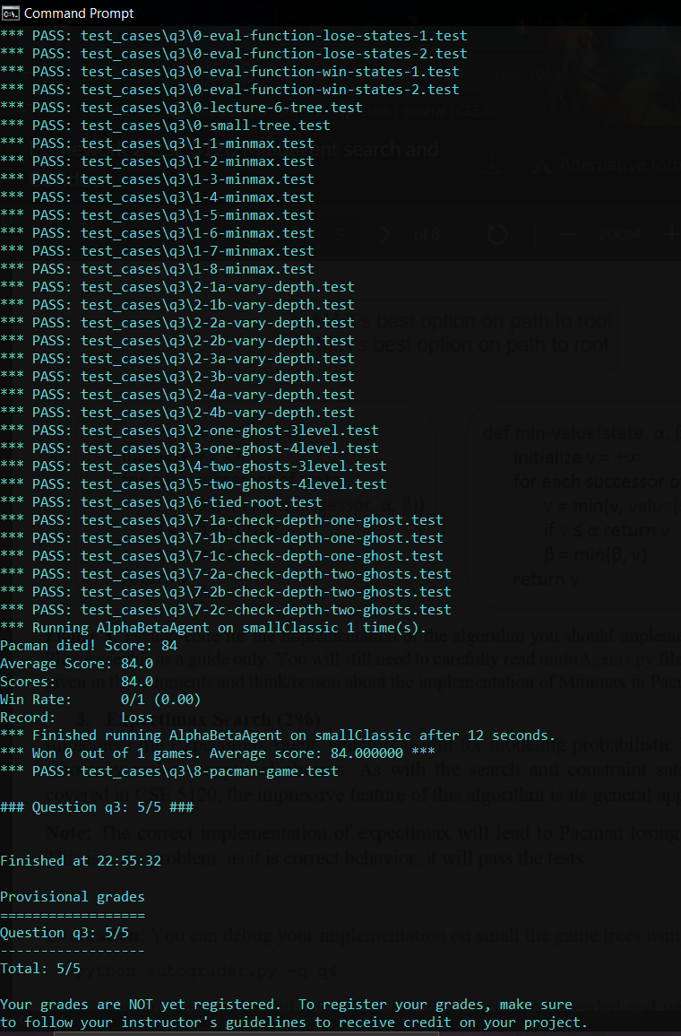

1. **Expectimax Search**

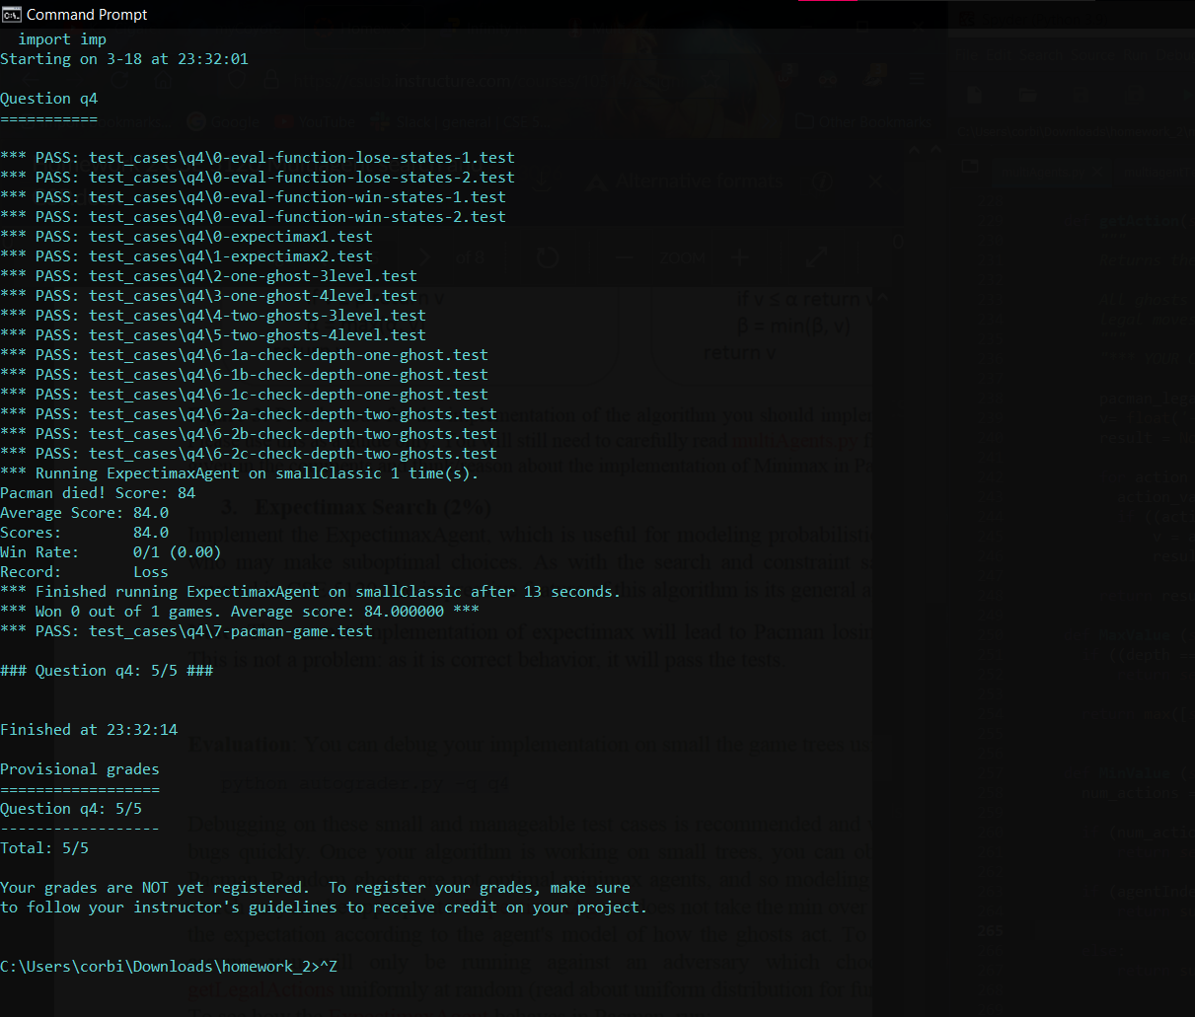

1. **Constraint satisfaction problems**

**1.**  
- Each n^2 spot on the n x n chess board corresponds to a variable. So, each knight is represented by a variable.

* Each variable can either by vacant or occupied as the domain of each variable is the set of squares.
* Every pair of knights is constrained, preventing them from being on the same square or on squares separated by a knight's move. Every pair of squares separated by a knight's move is limited, preventing them from being occupied simultaneously. So there is no global constraint.

**2.**

**-** Variable = C1, Domain = C, A

Variable = C2, Domain = A

Variable = C3, Domain = C, B

Variable = C4, Domain = C, B

Variable = C5, Domain = A, B

**Constraints:**C1 ≠ C2  
C2 ≠ C3  
C2 ≠ C4  
C3 ≠ C4

C2 C3

C5 C4

C1

Solution to CSP via tree structured CSPs is preferred because it allows any ordering to be chosen to ensure all the node’s parent precedes it in the ordering. Furthermore, the time complexity to solve it will be O(nd2).